Tradesolution Epd
A quick guide to Epd API v2



Tradesolution © 2025
Document version 1.0

Content
Change log 3
About this document 4
What is Epd? 5
STAND011 5
EPD Standard 11 6
Keywords 6
Registration of variant information in phases 7
The registration processes 7
Suppliers and recipients11 8
Product and units 8
A variant is a hierarchy of units and products 9
Unmarked variants 12
Summary 13
How to fetch a variant? 14
Product and unit 15
Product registration process 16
Prerequisite 17
Authentication 17
Fetching, creating and updating variant 18
Create a new empty variant draft 18
Create a new variant draft with prefilled values 19
Update an existing variant draft with values 22
Send a variant-draft to QA (manual quality assurance) for approval 23
Get variant draft data 23
Get published product data 23
Get modified variants 24
Sequence diagrams 24
Webhooks 26
Some of the events that can occur in Epd 26
Payload 27

Change log

About this document
This document is a quick guide to getting started with the Epd API v2 which was launched in 2024. The complete technical description of the REST API is documented in Swagger.
See: https://epdapi.tradesolution.no/v2/swagger/
If more information is needed contact epd@tradesolution.no.

What is Epd?
EPD is a master data management system for the Norwegian grocery segment. EPD gives access to product data to its recipients such as wholesalers, grocery chains and web shops.
The suppliers are responsible for having complete and correct product data of all the products they offer in grocery segment. EPD have an extensive quality assurance system to help them providing correct data.
For more information of EPD: www.tradesolution.no/tjenester/epd/

STAND011
EPD are based on principles from STAND011 which states the responsibilities between suppliers and retailers during the implementation of new products to the Norwegian grocery market.
The registration of new products is set to three default launch windows. Each launch window has a described process and responsibilities.
For more information: www.stand.no/standarder/stand011.

EPD Standard 11
The EPD API is based on the required information for a product described in EPD Standard 11.
The EPD Standard 11 is described in detail in the document «EPD_Standard_11.xlsx». See www.tradesolution.no/tjenester/epd/.
Active standards in EPD can be listed by the API call Standard.

Keywords
Explanation about some keywords that are being used in this document.
Keyword | Meaning
Product | A single item, lowest in the hierarchy, that is registered in Epd.  Example: The liquid milk is the product that can filled in multiple containers (Units).
Unit | A type of container that must contain one or more products/units
Base-unit | Name of the unit that most closely touches a product, often referred to as “retail unit”.
Inner-Case | Unit that contains one or more base-unit’s.
Case | Unit that contains one or more inner-case’s
Top | Unit that contains one or more base-unit’s, inner-case’s or case’s.
Variant | A variant is a sort of main-container that wraps at least one product and one unit. One product/unit can be included in multiple variants.
Supplier | A company, marked with “supplier”, registered in Epd. A supplier company can register one or more variants.
Receiver | A company, marked with “receiver”, registered in Epd. This company can fetch the variants, provided they have access to the variants. Access to variants is given by the supplier.
Epd number | A unique number that identifies a variant. All published variants will have an Epd number. Epd number will automatically be generated when a draft is approved.
GTIN | A unique number that identifies a unit. All published units will have a GTIN number.
OAuth 2.0 | OAuth is an authentication protocol that allows you to approve one application interacting with another on your behalf without giving away your password

Registration of variant information in phases
The new EPD Standard 11 divides the registration of the required variant information in sequential phases with individual deadlines. The overall process is referred to as a launch window (see STAND011).
This is a major shift from the previous standards of EPD where all required variant information had to be registered before a single deadline.
The EPD Standard 11 also require interaction from selected recipients.
The deadline of each phase is set to a given number of weeks before the variant should be launched in the stores. The launch date is defined as week ‘0’.
See overview of the registration process below.
The required product information for each phase are described in detail in EPD Standard 11.
The example below shows the phases prior to the launch date (week ‘0’):

The registration processes
- EPD F1 (phase 1) week -15
The deadline to the first registration phase are set to 15 weeks before launch (week -15). The required information needed for this phase must be registered and validated (passed QA) within the end of week -15. The status of the variant is set to: «Godkjent F1» in EPD and an event is sent to the event system (see paragraph «Events» for more information). Responsibility: Supplier
- EPD F1 Listing (phase 1 listing) week -8
Selected retailer gives information of which new variants registered by the suppliers in EDP F1 they want to sell (give listing to). The retailers must post the selected variants using the POST method of Produkt/IncludeInSortiment within the end of week -8. When the post is done, the event is sent to the event system. Responsibility: Selected retailers
Note: The retailers can also post variants that have been registered in previous launch windows with status «Godkjent F1» or «Godkjent F2» in EPD.
- EPD F2 (phase 2) week -6
The supplier must have registered and validated (passed QA) the variant information as required in EDP F2 within end of week -6. The variant will then get status «Godkjent F2» in EPD and the event is sent to the event system. Responsibility: Supplier
- EPD Sjekkpunkt (phase 3) week -3
The variants that are chosen to be listed in EPD F1 Listing must be sent to Tradesolution Sjekkpunkt for physical controls within week -3. If the variant passes the control a «checked date» (SistKontrollmaalt) is set for the controlled unit. Responsibility: Supplier
Information of the phases used in EPD can be listed by this API call Standardfase.
Suppliers and recipients11
Both suppliers and recipients are identified by GLN (Global Location Number).
- A recipient can get access to variant information from suppliers who have registered their variants in EPD
- A recipient can only get information from the suppliers they have subscribed to
- A supplier can deny a recipient access to one or many of their variants
- In EPD a supplier is called «produkteier»
- In EPD a recipient is called «mottaker»
API call to see all suppliers: Produkteier.
API call to see all recipients: Mottaker.
If a recipient wants to subscribe to variants from a new supplier it is possible to send «a request for information» call to the supplier. See ProdukteierRfi (documentation not available).
The supplier can then grant or deny the request.
Product and units
A variant in EPD consists of a set of products and units in a hierarchy. A variant is identified by a EPD number (EPDnr) and a unit is identified by GTIN (Global Trade Item Number). All EPD numbers and GTIN’s are connected to a supplier identified by GLN.
Be aware of that two suppliers can sell the same unit (GTIN) with different EPDnr. The unit (GTIN) will be registered by both parties. The combination of GTIN+GLN are always unique.
Three base units (basis) often referred to as customer units:
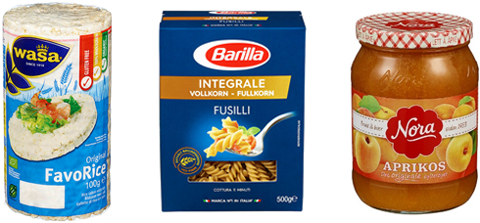
Three «mellom» (inner-case) units often referred to as trade units:
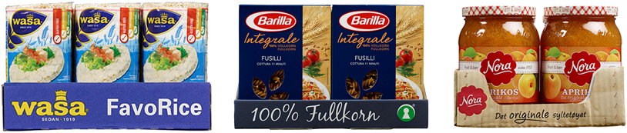

Examples of «topp»(top) units often referred to as distribution units:
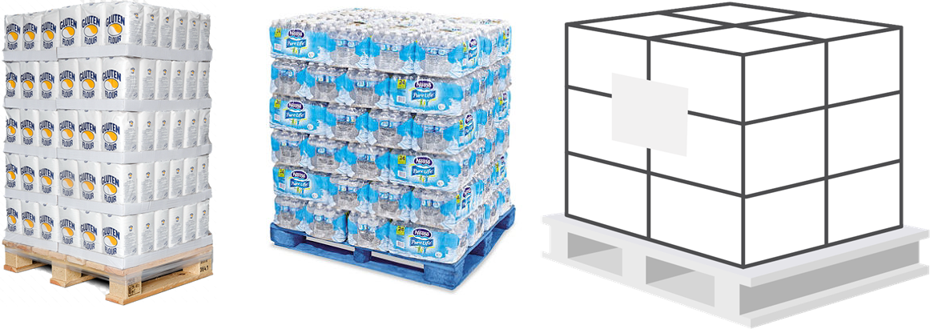

A variant is a hierarchy of units and products
To create the relation between two units in a variant the smaller unit in a variant have a reference to the unit above.
A hierarchy of units can have up to 4 levels. See the examples below of variants with different levels of units (note the naming of each level):
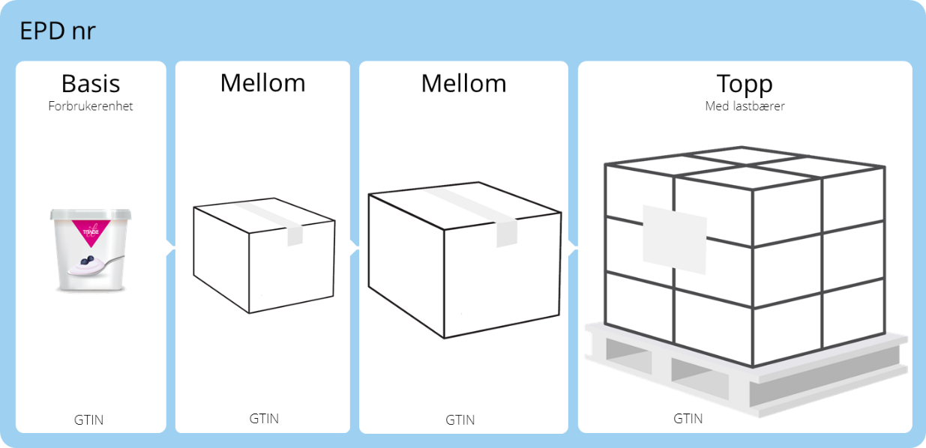

Note
One of the units (normally «mellom» or «topp») will be marked as the purchase unit from the supplier.

A variant can also have multiple base (basis) units or trade (mellom) units. Se the examples below:

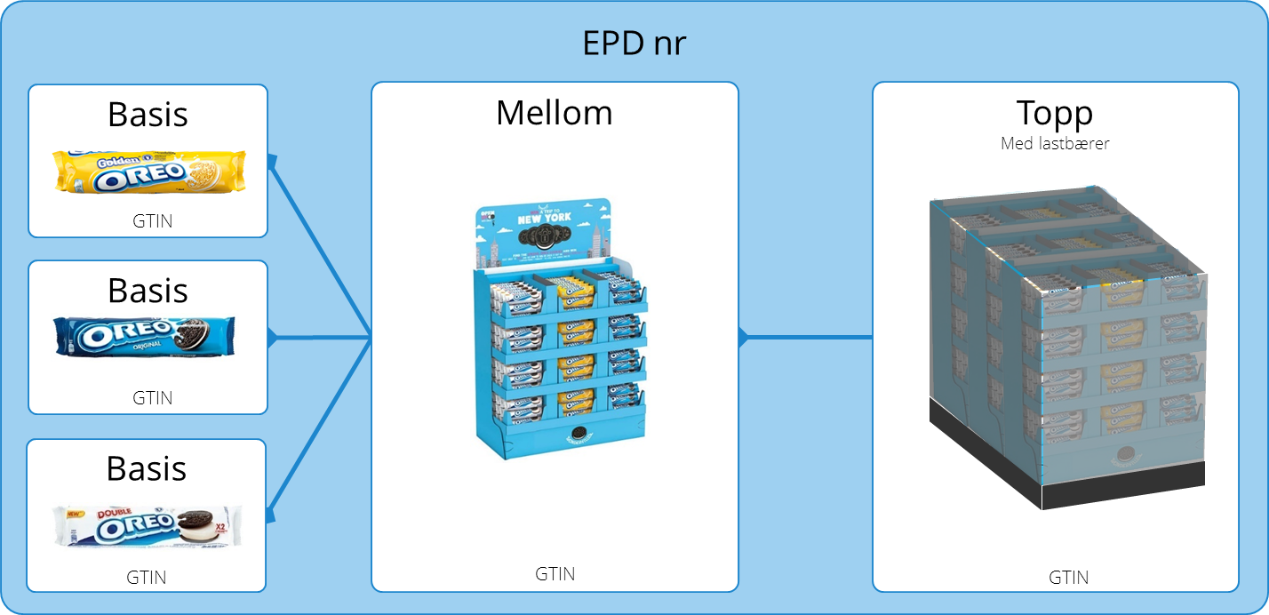

A base unit (basis) unit can also be included in many variant hierarchies (many variants will have the same base unit – a base unit can be part of many EPDnr). See the examples below with three different products (EPDnr) using the same base (basis) unit:
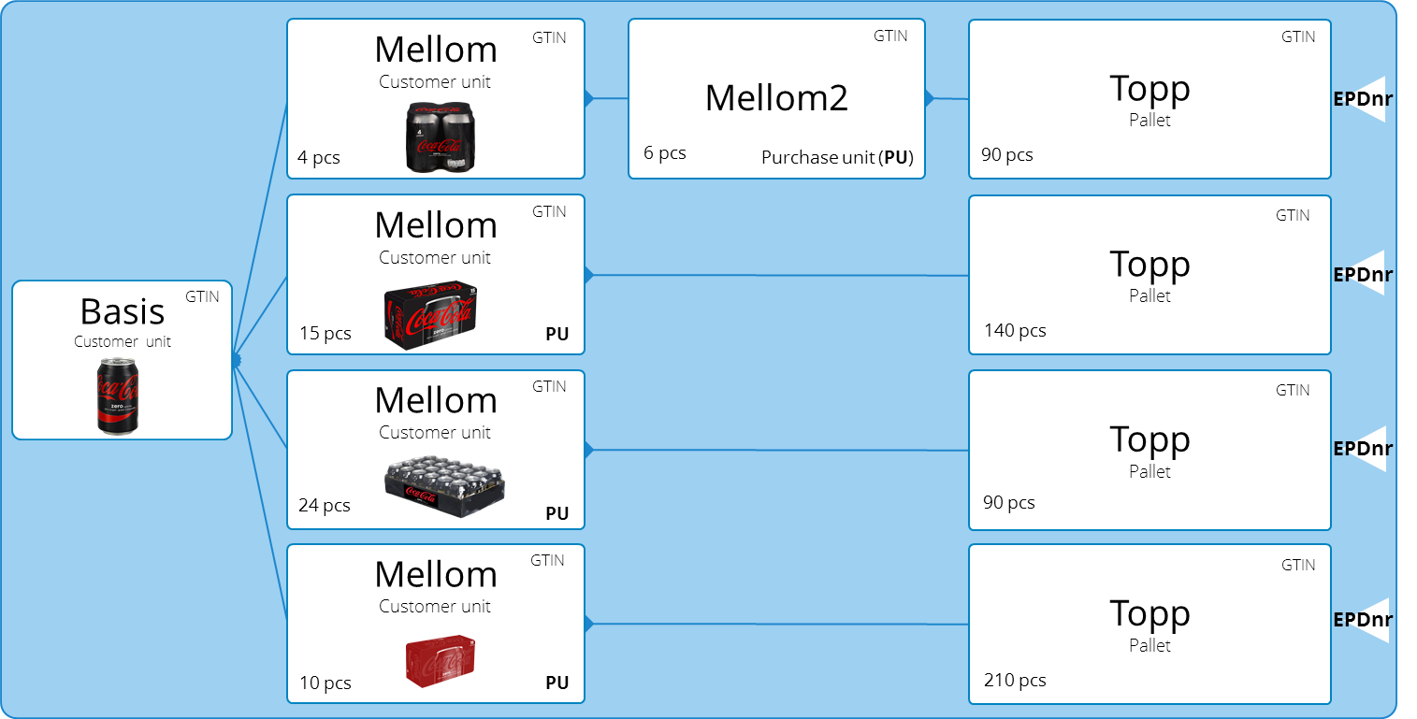

Unmarked variants
A basis unit can contain units without identification. The «unmarked variant» is not labelled with a barcode (GTIN) and can therefore not be sold separately. If there are several unmarked variants EPD will give them an ID («Umerketvariantnr») starting with ‘1’ and counting for each unmarked variant in the basis unit (GTIN). The «Umerketvariantnr» can only be used together with the GTIN of the basis unit.
See example below of a product which have four different unmarked variants which cannot be sold separately and have no barcode (GTIN):

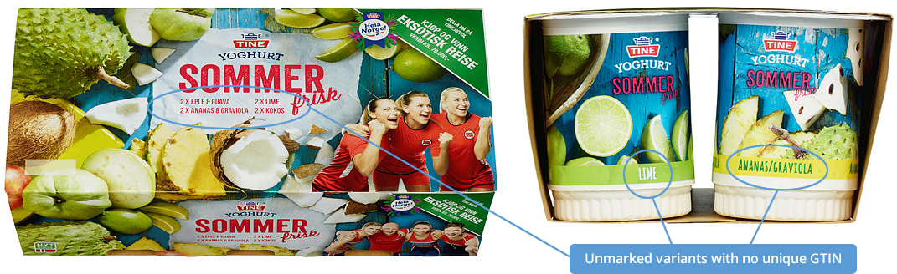

The basis level can include several «unmarked variants» identified by “Umerketvariantnr”:

Summary
- A variant is identified by a EPD number (EPDnr)
- A unit is identified by a GTIN (Global Trade Item Number)
- A variant can have up to 4 levels of units (hierarchy)
- A varoamt can be a mix of multiple «basis» or «mellom» units
- A “basis” unit can be shared by many variants
- The first level of the units is called «basis» in EPD (often referred to as a customer unit or base unit)
- The top level of the units is called «topp» in EPD (often referred to as a distribution unit)
- The levels between «basis» and «topp» (if any) are called «mellom» units
- A basis unit consists of one or many products

How to fetch a variant?

Product and unit
Examples of how a product is packed.

One product can be packed in 4 different units. Each set of units will have its own unique Epd number.
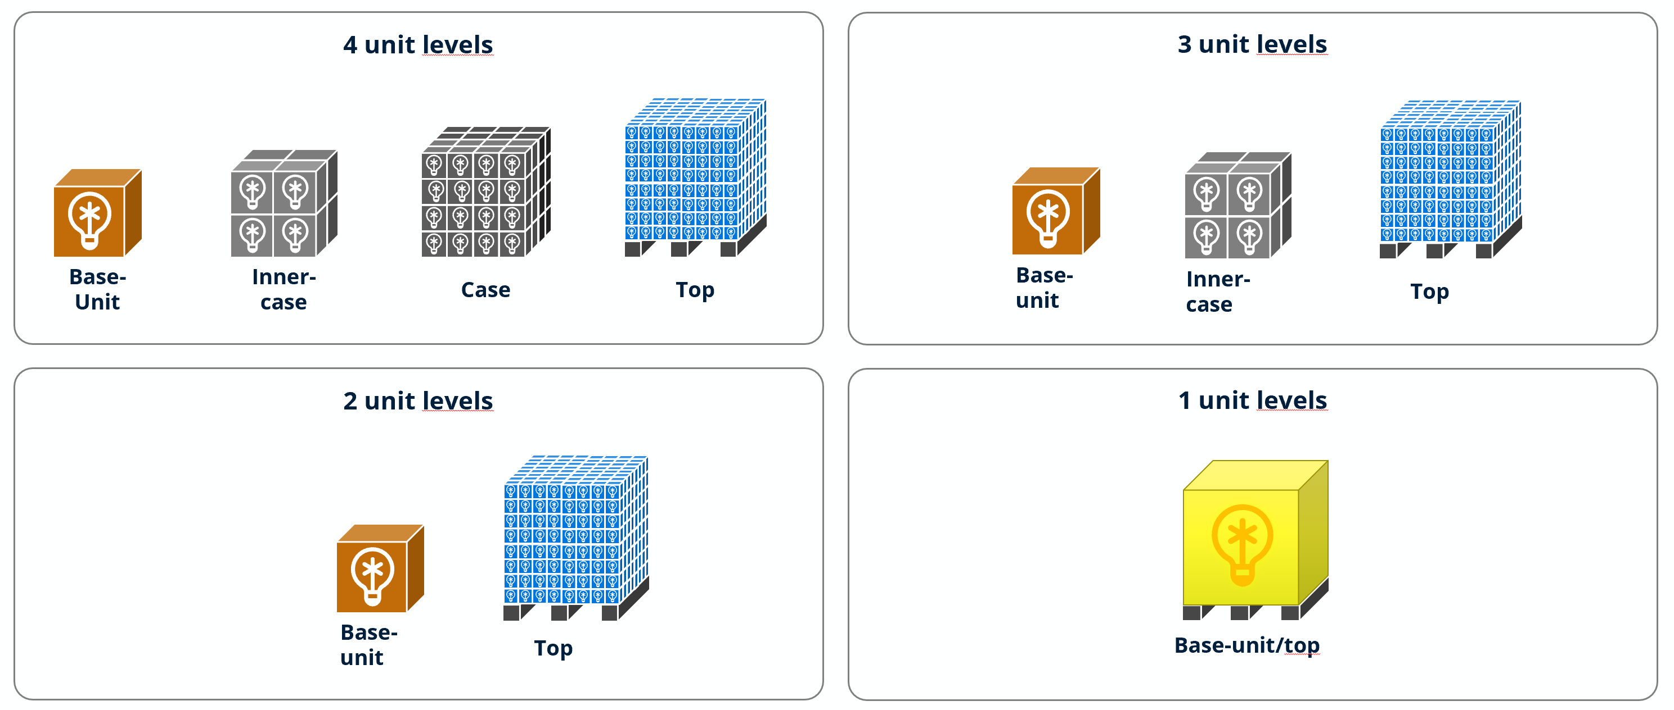

Product registration process
Overview

Prerequisite
Before fetching or updating data through Epd API you need to be registered in Tradesolution master database.
EPD API is using OAuth 2.0 as authentication protocol, so we need to provide you with an appid and secret before you can access the api. You will also receive a company identity guid that you will use when calling the api methods.
Access to different endpoints is based on the company type (receiver or supplier).
In general:
- Receivers can only fetch variants they have access to
- Suppliers can fetch their own variants and insert/update their variants

Authentication
EPD API uses OAuth2 bearer token authentication. You can get token by using this POST method:
POST https://login.microsoftonline.com/trades.no/oauth2/v2.0/token
Headers
Content-Type: application/x-www-form-urlencoded
Body
client_id=<insert_client_id>&client_secret=<insert_secret>&grant_type=client_credentials&scope=https://trades.no/TradesolutionApi/.default
Response
{
"token_type": "Bearer",
"expires_in": 35999,
"ext_expires_in": 35999,
"access_token": "eyJ0eXAiOiJ..."
}

The token is valid for 10 hours.

Add the token to the Authorization header when calling any api endpoint

Fetching, creating and updating variant
Functionality for creating a new variant or updating variant is only available for suppliers.

Create a new empty variant draft
The api provides several post methods from which you can create an empty draft.
When creating an empty draft, the structure of the variant is created. Standard and Phase (1 or 2) are also set on the variant and components.
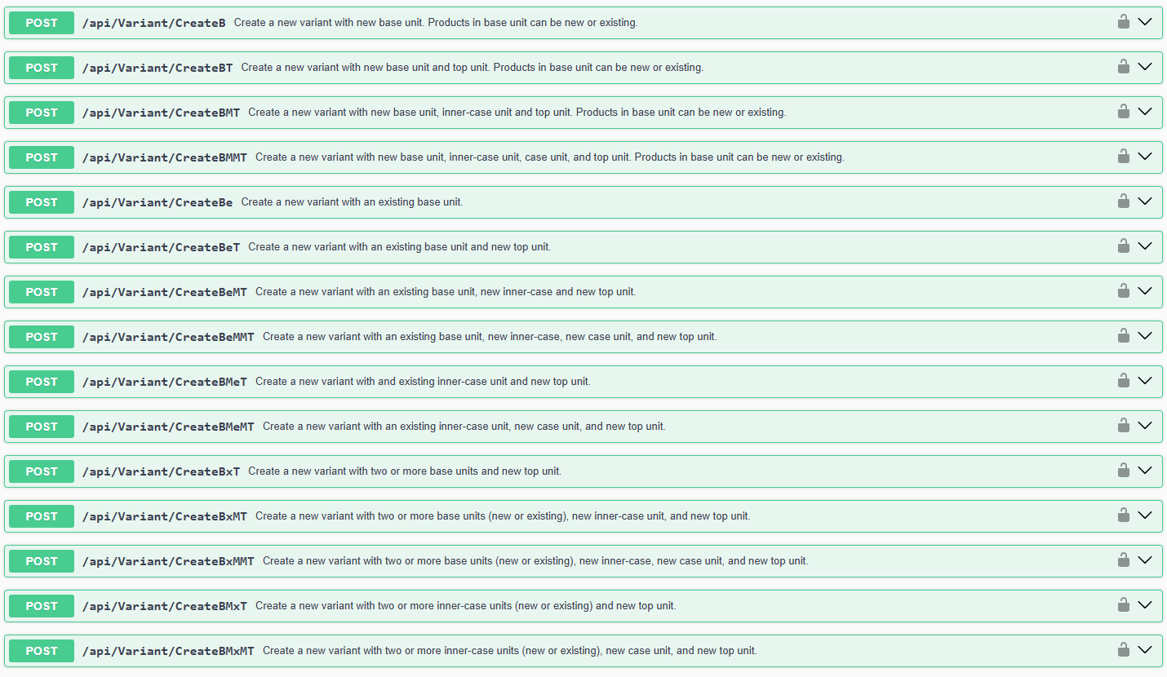
Lets create an empty draft with a base-unit, inner-case and top using /api/variant/CreateBMT.
The post body should look something like this:
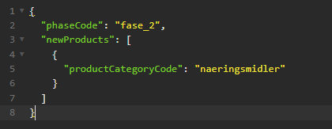
This will create a variant and 4 components (3 units and 1 product).
If the call is successful, the response will return the variantIdentityGuid:
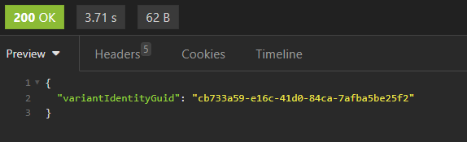
You can use variantIdentityGuid to get a more detailed response of the variant that was created.
Use the GET method:

Create a new variant draft with prefilled values
Use the following api endpoint to create a new variant with prefilled values:
Let’s create a variant with a basis, inner-case and top. The body of the request can look like this:
{
"Variant": {
"PhaseCode": "fase_2",
"ComponentList": [
{
"IsNew": true,
"IdentityGuid": "8ea4b640-6bd2-4b00-b89a-30be58b1a669",
"ComponentTypeCode": "unit",
"UnitLevelCode": "top",
"Data": {
"Standard": "epd_standard_11",
"FieldValues": {
"Unit_Fase": "fase_2",
"Unit_Egenskaper": "75cl",
"Unit_GTIN": 7036340068656,
"Unit_Markedsnavn": "Garzon Albarino Reserva 75cl",
"Unit_Hoyde": 140.0,
"Unit_Bredde": 80.0,
"Unit_Dybde": 120.0,
"Unit_Bruttovekt": 629800.0,
"Unit_ReturnerbarEmballasje": false,
"Unit_ResirkulerbarEmballasje": false,
"Unit_MaxTopplast": 400.0,
"Unit_Emballasjekode": "",
"Unit_ErForbrukerpakning": false,
"Unit_LastbaererKode": "1_1_pall_80_120_tre_chep",
"Unit_SpaceAvvikerFraLogistikkMaal": false,
"Unit_AntallBasispakningeriBredden": 2,
"Unit_AntallBasispakningeriDybden": 3,
"Unit_AntallBasispakningeriHoyden": 1,
"Unit_AntallPrLag": 21,
"Unit_AntallLag": 4,
"Unit_HoydePrLag": 31.2,
"Unit_AvvikendePakkemonster": false,
"Unit_GS1Databaarer": ""
}
}
},
{
"IsNew": true,
"IdentityGuid": "05b9675b-81b1-4f7c-ae57-f0668bb1e2a1",
"ParentIdentityGuid": "8ea4b640-6bd2-4b00-b89a-30be58b1a669",
"ComponentTypeCode": "unit",
"UnitLevelCode": "inner_case",
"Data": {
"Standard": "epd_standard_11",
"FieldValues": {
"Unit_Fase": "fase_2",
"Unit_Egenskaper": "75cl",
"Unit_GTIN": 7730951081843,
"Unit_Markedsnavn": "Garzon Albarino Reserva 75cl",
"Unit_Hoyde": 31.2,
"Unit_Bredde": 17.8,
"Unit_Dybde": 26.1,
"Unit_Bruttovekt": 7200.0,
"Unit_ReturnerbarEmballasje": false,
"Unit_ResirkulerbarEmballasje": false,
"Unit_Emballasjekode": "CT",
"Unit_ErForbrukerpakning": false,
"Unit_LastbaererKode": "",
"Unit_SpaceAvvikerFraLogistikkMaal": false,
"Unit_AntallBasispakningeriBredden": 2,
"Unit_AntallBasispakningeriDybden": 3,
"Unit_AntallBasispakningeriHoyden": 1,
"Unit_AvvikendePakkemonster": false,
"Unit_GS1Databaarer": "",
"Unit_AntallIPakningOver": 84
}
}
},
{
"IsNew": true,
"IdentityGuid": "6d7fe000-50cf-4f9c-bfa4-57e5d9a8e908",
"ParentIdentityGuid": "05b9675b-81b1-4f7c-ae57-f0668bb1e2a1",
"ComponentTypeCode": "unit",
"UnitLevelCode": "base_unit",
"Data": {
"Standard": "epd_standard_11",
"FieldValues": {
"Unit_Fase": "fase_2",
"Unit_Egenskaper": "75cl",
"Unit_GTIN": 7070292803569,
"Unit_Markedsnavn": "Garzon Albarino Reserva 75cl",
"Unit_Hoyde": 29.8,
"Unit_Bredde": 8.1,
"Unit_Dybde": 8.1,
"Unit_Bruttovekt": 1142.0,
"Unit_Nettovekt": 750.0,
"Unit_ReturnerbarEmballasje": false,
"Unit_ResirkulerbarEmballasje": false,
"Unit_Emballasjekode": "BO",
"Unit_ErForbrukerpakning": true,
"Unit_LastbaererKode": "",
"Unit_SpaceAvvikerFraLogistikkMaal": false,
"Unit_AvvikendePakkemonster": false,
"Unit_GS1Databaarer": "",
"Unit_Fyllingsgrad": 80.0,
"Unit_Mengde": 0.75,
"Unit_ErMerketMedUtsalgspris": false,
"Unit_MerketMedEgenskaper": false,
"Unit_MengdeTypeEnhet": "liter",
"Unit_Enhetsprisfaktor": 0.75,
"Unit_EnhetspristypeKode": "klar_til_aa_drikkes_volum",
"Unit_EnhetsprisbetegnelseKode": "liter",
"Unit_AntallIPakningOver": 6
}
}
},
{
"IsNew": true,
"IdentityGuid": "7b84ac9a-cf0b-4ddf-9db1-21fa3802ef70",
"ParentIdentityGuid": "6d7fe000-50cf-4f9c-bfa4-57e5d9a8e908",
"ComponentTypeCode": "product",
"Data": {
"Standard": "epd_standard_11",
"FieldValues": {
"Product_KategoriKode": "vin_brennevin_sterkol",
"Product_Beskrivelse": "Albariño Reserva",
"Product_HoldbarhetsdagerTotalt": 9998,
"Product_HoldbarhetsdagerTilProdusent": 9898,
"Product_HoldbarhetsdagerTilDistributor": 50,
"Product_HoldbarhetsdagerTilDetaljist": 50,
"Product_MVAKode": "generelt",
"Product_ErStorhusholdningsprodukt": true,
"Product_MinimumstemperaturCelsius": 1.0,
"Product_MaksimumstemperaturCelcius": 30.0,
"Product_Produksjonsland": "uruguay",
"Product_OpprinnelseOgOpphav": "",
"Product_TsVaregruppe": {
"Classifications": {
"tsvaregruppe": [
"130090"
]
}
},
"Product_Varemerker": [
"89993fb0-2703-489b-a675-e6b61a23c3f3"
],
"Product_AldersgrenseKode": "18_aar_alkohol",
"Product_Legitimasjonskrav": true,
"Product_AlkoholRapporteringsgruppeKode": "rapporteringsgruppe_2",
"Product_Alkoholprosent": 12.5,
"Product_Produsentnavn": "Garzon",
"Product_Aargang": 2022,
"Product_Polnummer": "7894201",
"Product_Vinkartongantall": 6,
"Product_VinSpritLagringsgradKode": "",
"Product_VinSpritEmballasjetypeKode": "",
"Product_VinSpritKorktypeKode": "",
"Product_Fase": "fase_2",
"Product_AntallIPakningOver": 1
}
}
}
],
"IdentificationNumber": {
"Name": "epdnr",
"Number": null
},
"Data": {
"Standard": "epd_standard_11",
"FieldValues": {
"Variant_Fase": "fase_2",
"Variant_LeverandorVarenr": "126157",
"Variant_TilgjengeligFraDato": "2024-12-01T00:00:00",
"Variant_UnitStructure": "b-m-t",
"Variant_BestillbarPakning": "05b9675b-81b1-4f7c-ae57-f0668bb1e2a1"
}
}
},
"Validate": false,
"SendToQA": false
}

A typical respone after you POST the request:
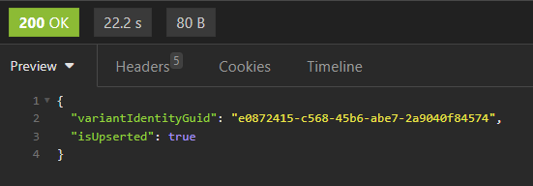
The returned IdentityGuid is the unique identifier for the newly created variant.
The response may return other values depending on if you have set “Validate” or “SendToQA” to true.
Notes:
- In the ComponentList make sure you fill out IdentityGuid and ParentIdentityGuid all items. ParentIdentityGuid does not need to be set on top unit.
- All IdentityGuid you set on a new component (isnew = true) will be replaced. You need to set them to build the hierarchical structure of the variant. When you later use variantIdentityGuid to GET the variant all componentIdentityGuids will be different from what you originally set.
- When you set “SendToQA: true” the system will trigger a validation after the variant has been created. If the variant is valid the system will send it to QA, otherwise it will remain as a draft.

Update an existing variant draft with values
Description of how to change field values or add new values to a draft.
Use the following api endpoint:

The response:
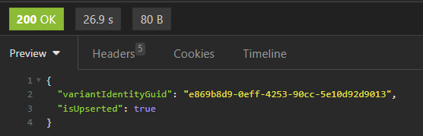
Notes:
- Create and update share the same “requestDto”.
- You cannot change the structure of a created variant. Meaning you cannot add or remove components to an existing draft.
- When updating make sure component.IdentityGuid and component.ParentIdentityGuid are correct.
- Even if you set Component.IsNew = true, it will not be considered in the update.
- In a new draft, meaning not approved yet, you are able to change all the field values of variant/units/products
- When you edit an approved variant, some fields will be locked (not editable).

Send a variant-draft to QA (manual quality assurance) for approval
When a variant-draft is sent to QA for approval it will be placed in a queue. A member of the QA team will pick a variant and manually check the values.
To be able to send a variant-draft to QA all mandatory fields need to be filled in variant, units and product(s). Also be aware that a variant will be locked until manual QA has approved or rejected it.
The endpoint to use when sending a variant-draft to QA:
POST /api/Variant/{variantIdentityGuid}/SendToQA

Get variant draft data
To get the variant draft use the endpoint:
GET /api/variant/{variantIdentityGuid}/Draft
Notice that draft data will not be available after a draft is approved/published. The reason behind this is because the draft is cleared once the draft is approved.

Get published product data
To get the variant data after approval use the endpoint:
GET /api/variant/{ variantIdentityGuid /Approved

Get modified variants
To get all modified variants within a date range use the endpoint:
GET /api/variant/LastModified/{fromDate}/{toDate}
Returns a list of variantIdentityGuids, that can be used to get the actual variant data.

Sequence diagrams

Simplified sequence diagram for creating a variant, then a variant and sending it to QA
Manual QA will approve the draft in timely matter. Simplified sequence diagram:

Webhooks
Epd supports webhooks. A webhook is an HTTP callback: an HTTP POST that occurs when something happens. The webhook will have a message or payload that are sent to a unique URL (provided by receiver/supplier)
Since webhook are event-based, they will execute when specific events occurs in Epd.
Some of the events that can occur in Epd:
Event code | Recommended for | Event description
produkt_godkjent_fase_1 | Receiver/Supplier | Occurs when a variant is approved in phase 1
produkt_godkjent_fase_2 | Receiver/Supplier | Occurs when a variant is approved in phase 2
produkt_feilmerket_fase_1 | Receiver | Occurs when a variant/unit/product field is error marked, and the variant is in phase 1
produkt_feilmerket_fase_2 | Receiver | Occurs when a variant/unit/product field is error marked, and the variant is in phase 2
produkt_nedlagt | Receiver | Occurs when a variant is discontinued
produkt_endret_antall | Receiver | Occurs when “number of items above” in a unit has changed.
produkt_endret_gtin | Receiver | Occurs when gtin on a unit has changed.
produkt_endret_mengde | Receiver | Occurs when “mengde” on a unit has changed.
produkt_godkjent_sjekkpunkt_med_endringer | Reciever/Supplier | Occurs when a variant is validated and approved by EPD Sjekkpunkt with edits/updates
produkt_feilmerket_sjekkpunkt | Supplier | Occurs when a variant is error marked by EPD Sjekkpunkt
sokt_om_produktendring | Receiver | Occurs when a supplier is requesting to change a locked field (that requires an application to be unlocked) in variant/unit/product

Suppliers/receivers can decide which events they want to subscribe to. Some of the events are only available for receiver only or supplier only.

All calls are sent over the https protocol. It is important that these URLs are shared in a secure way.
A URL path can contain numbers and letters so that it only receives calls when somebody knows the exact URL. This seem to be to most common way to secure a webhook call, and we recommend that you use it.
Example of a URL that is hard to guess:
- Microsoft Teams Webhook URL (path): https://eanreg.webhook.office.com/webhookb2/xxx296f8-2327-460f-860b-4f525021f913@ead5a9b8-4a2d-4d79-b8f5-3beff6730xxx/IncomingWebhook/xxxd0347bca945ae8047e83455fa0a31/3b6121e9-9334-4da9-b3cf-21acce00bxxx
- Slack Webhook URL (path): https://hooks.slack.com/services/T00000000/B00000000/XXXXXXXXXXXXXXXXXXXXXXXX

Another alternative is to send a query parameter that can be verified after the call is received:
Azure functions URL with code query parameter: https://api.azurewebsites.net/api/Item?code=XXXBdzbwI3kX2hC15daVPUNpU/N9rthWnVsV/J5L1tnNmgU6XXX==
Custom HTTP Request header
Webhook calls can be sent with a custom HTTP request header. Both key and value can be provided by you, and these values can be verified after the call is received.
What do we not support?
We don’t support IP filter in firewall because our outgoing IP changes and will cause the event to not reach destination webhook URL.
We don’t support OAuth2 on webhook events.

Payload
The events will be posted as JSON in the following format:
{
"eventId": GUID,
"event": "name_of_event",
"source": "nameOfSystemThatSentEvent",
"payload": {
"property1": "value1",
"property2": "value2",
},
"triggeredBy": “name or null”,
"triggeredAt": "2025-03-07T11:52:56.409Z",
"apiUrl": null,
"userInterfaceUrl": "https://someurl",
"displayMessage": "Message in event",
"eventTypeDisplayNameToUseInsteadOfDefaultName": "Description of event"
}

That means that an event object can be posted, and each event can contain different payloads. An example event could look like this:
{
"eventId": "a6f2150e-91c5-4ccc-b071-b746f9131358",
"event": "produkt_godkjent_fase_2",
"source": "EPD",
"payload": {
"KladdProduktID": 229222,
"EpdNummer": 260 (fake),
"IdentificationNumber": 260 (fake),
"VariantName": "Mikro Extra",
"Produktnavn": "Mikro Extra",
"VariantIdentityGuid": "849d8e15-35c7-48f5-a711-977517055a14",
"IsNewVariant": false,
"NyttEpdNr": false
},
"triggeredBy": null,
"triggeredAt": "2025-03-07T11:43:25.569Z",
"apiUrl": null,
"userInterfaceUrl": "https://epd.tradesolution.no/variant/849d8e15-35c7-48f5-a711-977517055a14/approved",
"displayMessage": "EPDnr '260', 'Mikro Extra' ble godkjent av QA",
"eventTypeDisplayNameToUseInsteadOfDefaultName": "EPDnr godkjent i fase 2"
}

It is important to design the system that receives a webhook call as idempotent. An idempotent operation is one that has no additional effects if it is called more than once with the same input parameters. If two events with the same payload is sent, the receiving system should end up in the same state after both have been received. The same holds true if these events trigger information retrieval (I.e. a get request to Epd API) and the same information is returned both times. However, if data in Epd has changed during the time between the two calls, the calling system should end up in different states after each call.
The preferred reception method is to store or queue the received message and then return success (200 OK). Further processing should occur independently from the webhook call. If a webhook is called with an event that it currently does not support or handle, it should ignore it (and ideally log it internally) and return success (200 OK).

How to subscribe?

You will get access to the portal tilganger.tradesolution.no where you can subscribe to events.
Access is provided by Tradesolution.

